Poster 3 - Everyone is good at something

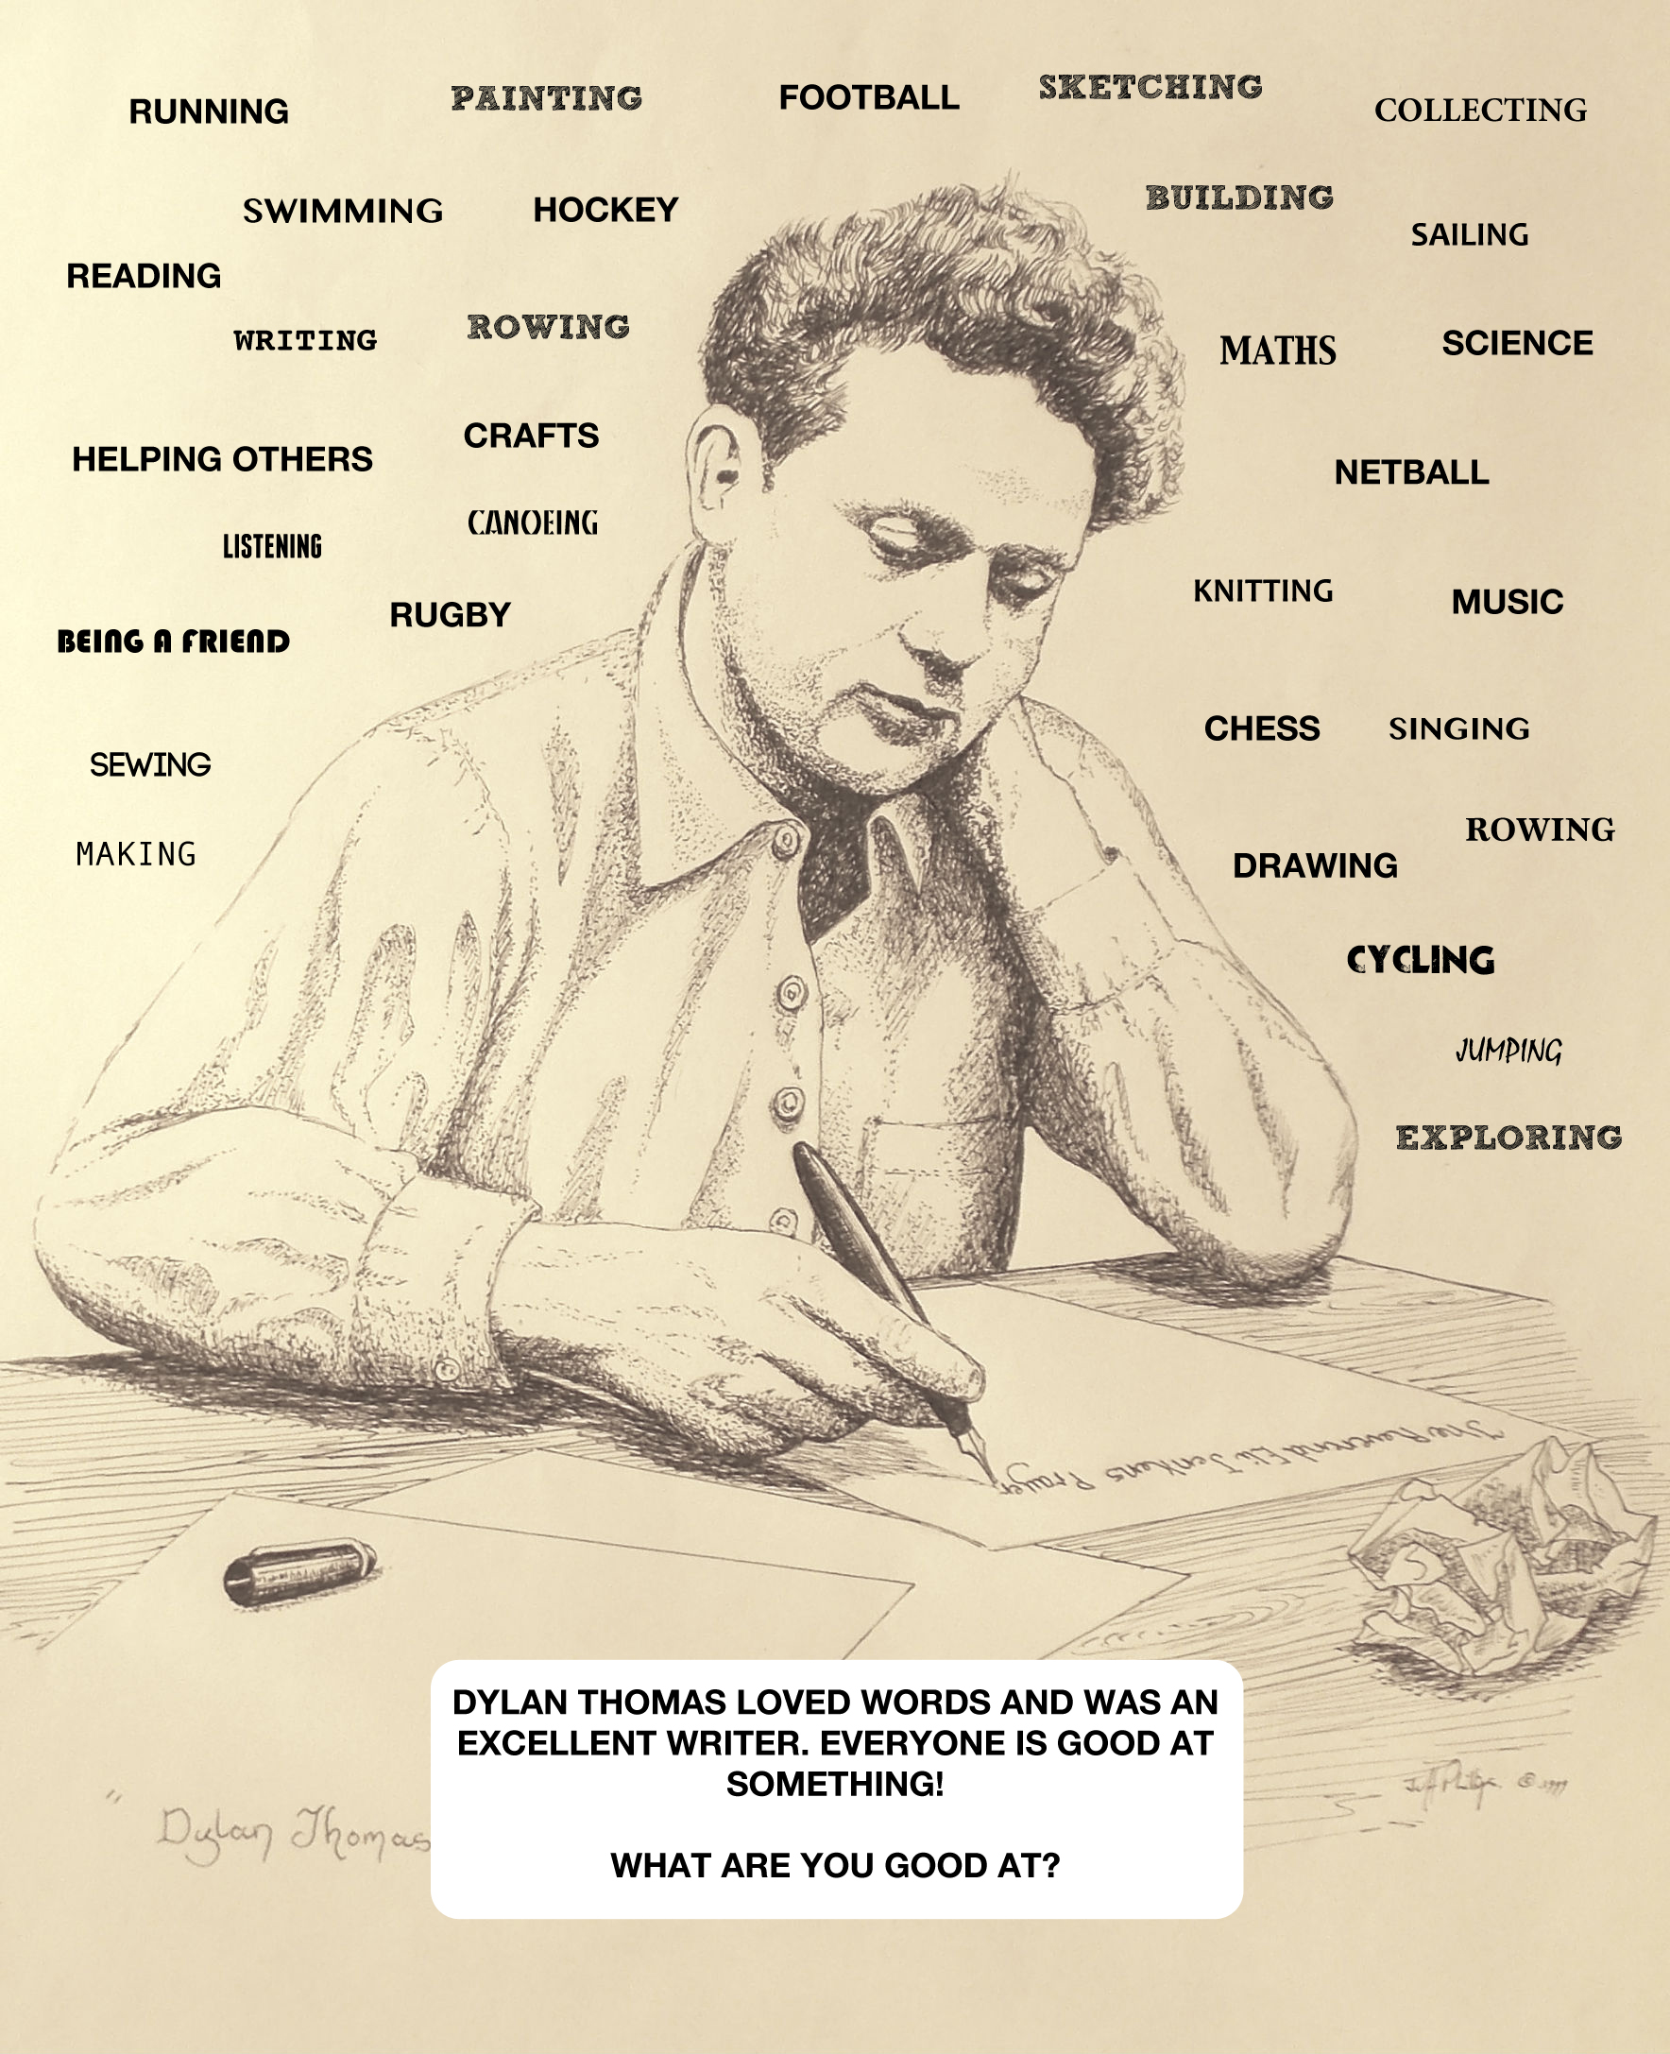

Some teaching ideas

- As a class, view the clip of Hanna Ellis talking about Dylan Thomas: 'EveryoneIsGoodAtSomething' in Resources.

- Have an identity circle inviting learners in if they have - brown hair, glasses, can speak more than one language, etc. Explain that these are things that make up their identity. Play again using things that the learners think that they are good at - these can be academic, sports or in any field.

- Have the children stand in a circle. Go round each person and have the class say something they are good at.

